PRA - 1
Enter Python Internal Marks ->30
Enter PHP Internal Marks ->25
Enter Mern Internal Marks ->33
Enter DMM Internal Marks ->45
Enter CDP1 Internal Marks ->48
Enter Python External Marks ->50
Enter PHP External Marks ->55
Enter Mern External Marks ->56
Enter DMM External Marks ->58
Enter CDP1 External Marks ->50
The Result is Distinction Grade with 90.0 %, obtained total marks 450 out of 500

PRA - 2
Enter name of friends separated by comma(,) ->paras,janvi,jay,leen
paras will deliver the session

PRA - 3
Enter all heights seperated by a space==>150 160 170 180
165.0

PRA - 4
Welcome to Password Generator
How many letters you want in Pasword-> 2
How many letters you want in Pasword-> 2
How many letters you want in Pasword-> 2
hp56$%

PRA - 5
Enter first number: 20
Enter operator (+, -, *, /): +
Enter second number: 30
Result: 50.0

PRA - 6
Enter 'add', 'view', 'delete', or 'exit': add
Enter a task: 10
Enter 'add', 'view', 'delete', or 'exit': add
Enter a task: 20
Enter 'add', 'view', 'delete', or 'exit': view
Tasks: ['10', '20']
Enter 'add', 'view', 'delete', or 'exit': delete
Enter a task to delete: 10
Enter 'add', 'view', 'delete', or 'exit': view
Tasks: ['20']
Enter 'add', 'view', 'delete', or 'exit': exit

PRA - 7
Enter 'add', 'view', 'delete', or 'exit': add
Enter contact name: jay
Enter phone number: 7046705720
Enter 'add', 'view', 'delete', or 'exit': add
Enter contact name: paras
Enter phone number: 9898365265
Enter 'add', 'view', 'delete', or 'exit': view
Contacts: {'jay': '7046705720', 'paras': '9898365265'}
Enter 'add', 'view', 'delete', or 'exit': delete
Enter contact name to delete: jay
Enter 'add', 'view', 'delete', or 'exit': view
Contacts: {'paras': '9898365265'}
Enter 'add', 'view', 'delete', or 'exit': exit

PRA - 8
Lines: 2, Words: 4, Characters: 27

PRA - 9
Enter 'add', 'view', or 'exit': add
Enter category: Food
Enter amount: 200
Enter description: Lunch at cafe

Enter 'add', 'view', or 'exit': add
Enter category: Transport
Enter amount: 50
Enter description: Bus ticket

Enter 'add', 'view', or 'exit': view
Total Expenses: 250.0
{'category': 'Food', 'amount': 200.0, 'description': 'Lunch at cafe'}
{'category': 'Transport', 'amount': 50.0, 'description': 'Bus ticket'}

Enter 'add', 'view', or 'exit': exit

PRA - 10
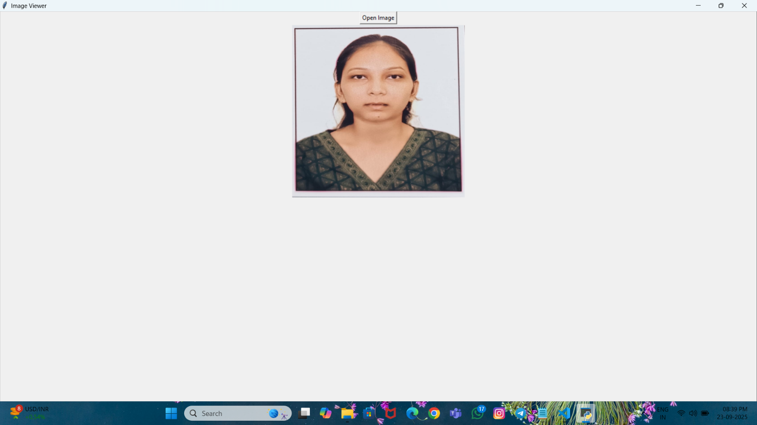

PRA – 11
Enter a sentence: I really love this product.
Sentiment: Positive

Enter a sentence: This is the worst experience ever.
Sentiment: Negative
Enter a sentence: The book is on the table.
Sentiment: Neutral

